

**ATTENTION**

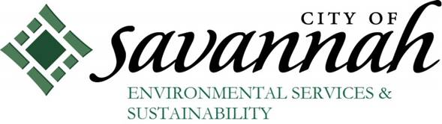

**U.S. EPA Brownfield Grant for the MLK /Montgomery Street Corridor**

The City of Savannah is applying for a **U.S. EPA Brownfield Grant** that will provide funding to identify, inventory, and assess the potential for contamination on properties within the MLK/Montgomery St. corridor.

Come and learn how this effort could help our community:

* Clean up environmental contamination,
* Improve community health,
* Identify key properties for revitalization

**Date: October 6th, 2015**

**Time: 5:30p.m. – 7:00p.m.**

**Location: St. Luke Baptist Church (418 West 38th Street)**